Rebel Training

Safer Recruitment Policy

Detailing arrangements for:

Initial Safer Recruitment Procedures

Ongoing Safeguarding Procedures

Responsibilities

DBS Risk Assessment Framework

Equality and Diversity

Confidentiality and Data Protection

**Centre Details**

|  |  |  |  |
| --- | --- | --- | --- |
| Centre Name: | Rebel Training | Centre Number: | TBC |

**Plan Details**

|  |  |  |  |
| --- | --- | --- | --- |
| Date Published: | 2nd April 2025 | Version Number: | 1.1 |
| Review Cycle: | Annual | Date of Next Review: | 2nd April 2026 |
| Status: | **Approved** | | |
| Individual Responsible for Policy: | | Joanne Vertannes | |



Introduction 2

Stage One: Initial Safer Recruitment Procedures 4

Stage Two: Ongoing Safeguarding Procedures 12

Responsibilities 16

DBS Risk Assessment Framework 18

Equality and Diversity 22

Confidentiality and Data Protection 24

Policy Review 27

# Introduction

#### **Purpose of the Policy**

The purpose of this policy is to outline the procedures and principles for safer recruitment within our organization. As a non-profit providing Early Help services under statutory duties, it is imperative that we maintain high standards of recruitment to ensure the safety and well-being of children and vulnerable adults. This policy sets out the practices and procedures to ensure that all staff, volunteers, and contractors are recruited with due diligence, safeguarding, and child protection considerations in mind.

#### **Scope of the Policy**

This policy applies to all recruitment activities, including the hiring of staff, volunteers, and contractors who will work with children, young people, or vulnerable adults within our service. It covers all stages of the recruitment process, including job advertisements, application forms, interview procedures, pre-employment checks, and induction. All staff involved in recruitment are expected to follow the guidelines set out in this policy to ensure compliance with relevant legislation and best practices in safeguarding.

#### **Definition of Safer Recruitment**

Safer recruitment refers to the process of ensuring that all individuals recruited into positions within the organization are suitable to work with children and vulnerable adults. It includes a series of pre-employment checks, interviews, and other steps designed to assess an individual's suitability for the role. The aim is to prevent unsuitable candidates from being employed or involved in any capacity with vulnerable groups, ensuring a safe environment for those in our care.

### **Linked Policies**

This policy should be read in conjunction with the following Rebel Training Group policies:

* Safeguarding Policy;
* Staff and Volunteers Code of Conduct;
* Health and Safety Policy;
* Missing Children Policy;
* Business Continuity Plan;
* Complaints Policy;
* Whistleblowing Policy;
* Disciplinary and Grievance Policy;

### **Legal Framework**

The following key pieces of legislation provide the foundation for this Safer Recruitment Policy:

* **The Safeguarding Vulnerable Groups Act 2006**
* **Keeping Children Safe in Education (KCSIE), 2024**
* **The Children Act 1989 & 2004**
* **The Equality Act 2010**
* **The Disclosure and Barring Service (DBS) Checks**
* **The Childcare (Disqualification) Regulations 2009**

*For a full list of* ***all*** *legalisations (brief description and links) this policy has been aligned to see* *Appendix 1**.*

### **Principles of Safer Recruitment**

The following principles underpin the safe recruitment process and guide the practices and procedures outlined in this policy:

#### **Child Protection and Welfare**

Our primary aim in recruitment is to ensure the protection and welfare of children and vulnerable adults. All recruitment practices are designed to prevent unsuitable individuals from gaining access to roles that would allow them to harm children or vulnerable individuals. The recruitment process should assess an individual's ability to safeguard children and uphold the highest standards of child protection.

#### **Equal Opportunities and Non-Discrimination**

We are committed to ensuring equal opportunities for all candidates in our recruitment process. Our recruitment practices are designed to be inclusive and free from discrimination based on race, gender, disability, age, sexual orientation, or any other protected characteristic. The recruitment process must ensure fairness and transparency while prioritising child safeguarding.

#### **Ensuring Transparency and Accountability**

The recruitment process must be transparent, with clear procedures for shortlisting, interviewing, and selecting candidates. All decisions made during recruitment must be documented, ensuring accountability in the recruitment process. This includes making clear and objective decisions based on candidates' qualifications, experience, and suitability for the role.

#### **Confidentiality and Privacy**

All personal data collected during the recruitment process, including information about criminal records and safeguarding checks, must be handled in accordance with data protection laws. Confidentiality must be maintained at all stages of recruitment to protect candidates' privacy. Any information about candidates that is gathered during the recruitment process should only be shared on a need-to-know basis, in line with safeguarding requirements.

# Stage One: Initial Safer Recruitment Procedures

#### Advertising

The aim of advertising is to attract a wide range of high-quality candidates from diverse backgrounds. See our Equality, Diversity and Inclusion Policy.

All advertisements for posts, whether in newspapers, journals, or online, will include a statement confirming that:

Rebel Training is committed to safeguarding and the welfare of children. All candidates who may come into contact with children and young people, either online or in person, will be required to undergo an enhanced DBS check or equivalent.

The wording of job adverts will clearly highlight the Centre’s commitment to safeguarding and will help deter, reject, or identify people who might abuse children and young people or are otherwise unsuited to working with them by stating the appropriate procedures for appointing staff and volunteers.

All documentation relating to applicants will be treated confidentially in accordance with the Data Protection Act (DPA 2018) or Data Privacy Regulations. See GDPR and Data Protection Policy.

It is unlawful for Rebel Training to employ anyone who is barred from working with children. All applicants will be made aware that providing false information is an offence and could result in the application being rejected or summary dismissal if the applicant has been selected, and referral to the police and/or the DBS (England and Wales).

#### Job Descriptions and Person Specifications

A job description is a key document in the recruitment process and must be finalised prior to taking any other steps in the recruitment process. It will clearly and accurately set out the duties and responsibilities of the job role.

The person specification is of equal importance and informs the selection decision. It details the skills, experience, abilities, and expertise that are required to do the job. The person specification will include a specific reference to suitability to work with children. *See* *Appendix 2* *for* ***Example Job Description.***

**Safeguarding and Legal Compliance Statement:**

*At Rebel Training, we are committed to ensuring a safe and supportive environment for all young people. In line with our safeguarding procedures,* ***it is a criminal offence to apply for this position if you are barred from working with children or vulnerable adults.*** *All successful candidates will be required to undergo a full Disclosure and Barring Service (DBS) check as part of the recruitment process.*

#### Personnel File and Safer Recruitment Checklist

A personnel file checklist will be used to track and audit all recruitment paperwork, which will be securely stored on Rebel Training’s restricted HR data management system in Microsoft 365 SharePoint.

A Digital Recruitment Checklist supports the Safer Recruitment Team (Hiring managers, DSL and SCR administrators) to ensure the correct process is followed for Safer Recruitment actions. *See* *Appendix 6* *for paper version of the Recruitment Checklist.*

#### Application Forms

Rebel Training will only accept copies of a curriculum vitae alongside an application form. A curriculum vitae on its own will not provide adequate information.

Rebel Training will also provide a copy of the Centre’s Safer Recruitment Policy as a link in the application pack or refer to a link on its website.

Applicants must provide:

* Personal details, including current and former names, current address, and national insurance number
* Details of their present (or last) employment and reason for leaving
* Full employment history (since leaving school, including education, employment, and voluntary work) with explanations for any gaps
* Qualifications, including the awarding body and date of award
* Details of referees/references (see below for further information)
* A statement of personal qualities and experience relevant to the role and how they meet the person specification

#### Self-declaration Form

As part of the safer recruitment process, all candidates will be asked to complete a self-declaration form regarding their criminal record and any other information that may render them unsuitable to work with children. This form will request disclosure of:

* Criminal history
* Inclusion on the children’s barred list
* Prohibitions from teaching or school management
* Relevant overseas information
* Any known police or social care involvement

The self-declaration form will be reviewed **only after** the shortlisting, interviews, and reference checks are completed, and before a conditional offer is made.

*See* *Appendix 3**:* ***Self-Declaration (Paper Version)***

#### References

References for shortlisted applicants will be requested immediately after shortlisting. This allows any concerns raised to be explored further with the referee and taken up with the candidate at the interview. The only exception is where an applicant has indicated on their application form that they do not wish their current employer to be contacted at that stage. In such cases, this reference will be taken up immediately after the interview.

All offers of employment will be subject to the receipt of a minimum of two satisfactory employment references. One reference must normally be from the applicant's current or most recent employer. If the current or most recent employment did not involve work with children, then the second reference should be from the employer with whom the applicant most recently worked with children. Where an applicant has had more than two roles within the last two years, references will be obtained from all employers within this period.

For non-education/early help roles at Rebel Training, references from the two most recent employers must be provided.

The Centre may, at its discretion, require further references to ensure suitability. References must be obtained directly from the referee using a company email address. The Centre will not accept open testimonials or references provided by the applicant.

#### Shortlisting

At least two individuals will conduct the shortlisting process, ensuring a consistent approach. Gaps in employment or inconsistencies in applications will be explored.

Online searches may be conducted as part of due diligence on shortlisted candidates, with applicants being informed of this possibility.

#### Interviews

Interviews will be conducted face-to-face or online, with a minimum of two interviewers present. The interview will assess the applicant’s ability to fulfil the job description and meet the person specification. Any anomalies or safeguarding concerns will be addressed in line with Safer Recruitment training. Safer recruitment interview questions related to safeguarding practices will be included. *See* *Appendix 4* *for example questions.*

At least one interviewer will have completed Safer Recruitment training or a refresher course.

Unsuccessful applicant documents will be retained for six months in accordance with GDPR and the Equality Act 2010, after which they will be securely destroyed or deleted.

### **Conditional Offer of Employment**

Rebel Training adheres to the guidelines set out in Keeping Children Safe in Education (KCSIE) 2024 and the Education (Independent School Standards) Regulations 2019 when conducting pre-employment checks.

A formal offer of employment is conditional upon the following:

* Agreement on a mutually acceptable start date and contract signing.
* Verification of identity.
* Receipt of two satisfactory references.
* Verification of professional qualifications.
* An enhanced DBS check (or equivalent) for roles involving regulated activity.
* Confirmation that the applicant is not barred from working with children.
* Verification of medical fitness.
* Any required overseas checks.
* Online searches and reviews.

Rebel Training is only permitted to check the Children’s Barred List if an individual will be engaging in **regulated activity**. Each role will be assessed to determine whether it constitutes regulated activity, ensuring the correct checks are carried out.

### **Regulated Activity**

People working at Rebel Training will be carrying out regulated activity with children if they meet all 5 of the following criteria:

* They work in the establishments on more than 3 days in a 30-day period, or once overnight between 2am and 6am with the opportunity for face-to-face contact with the children
* They have the opportunity, because of their job, to have contact with the children in the establishment
* They work there for the purpose of the establishment (individual’s primary role is directly related to the operation or function of the business)
* It is not temporary or occasional work
* It is not a supervised volunteer role

*For more guidance, see* [*Regulated activity with children in England and Wales (Updated 21 February 2025)*](https://www.gov.uk/government/publications/dbs-guidance-leaflets/regulated-activity-with-children#specified-establishments-with-children)

The Children's Barred List is automatically checked as part of an Enhanced DBS check, which includes checks against both the Children’s and Adults' Barred Lists.

For administrative staff who have regular contact with children but do not engage in regulated activity, a Basic DBS check will be conducted as part of the pre-employment checks.

### **Proof of Identity, Right to Work, & Verification of Qualifications and/or Professional Status**

All applicants invited for interview at Rebel Training will be required to provide identification documentation, such as a passport or driving licence, as proof of identity and eligibility to work before the interview. Rebel Training does not discriminate based on age but requires both a full birth certificate and photo identification.

If an applicant claims a name change via deed poll, marriage, adoption, or statutory declaration, they will need to provide documentary evidence of this change.

Additionally, applicants must demonstrate that they have obtained any academic or vocational qualifications legally required for the position and claimed in their application form. Rebel Training reserves the right to verify the authenticity of these documents where necessary.

### **Overseas Checks**

If Rebel Training deems the DBS certificate (or equivalent) insufficient due to it not covering offences committed abroad, we will require evidence of checks from the applicant’s country of origin (or any other countries where they have lived) before confirming the appointment.

An overseas check will be required for applicants who have lived or worked abroad for three months or more in the last five years, in line with ISI requirements. The Home Office has published updated guides on available checks from different countries. If a UK national returns after working abroad, they must obtain a certificate of good conduct or equivalent from the relevant country or countries.

Rebel Training may request additional references from countries that do not provide criminal record checks or if an overseas criminal record check is delayed. Should an employee need to start before receiving the overseas police check, Rebel Training will confirm the start date once a risk assessment and all other pre-employment checks (including DBS and reference checks) are in place.

### **Contractors, Agency Staff, and Volunteers**

Contractors engaged by Rebel Training must conduct the same checks for their employees as the Centre is required to do for its staff and volunteers. The Centre requires confirmation (e.g., viewing the relevant documentation) that these checks have been completed before the contractor’s employees are allowed to commence work at Rebel Training.

Similarly, agencies providing staff and volunteers to the Centre must complete the same pre-employment checks that Rebel Training would complete for its own staff and volunteers. Confirmation that these checks have been carried out must be provided before any agency personnel can begin work at the Centre.

### **Visiting Speakers (and Prevent Duty)**

The Prevent Duty Guidance requires Rebel Training to have clear protocols to ensure that all back-office staff, volunteers, and visiting speakers—whether invited by staff, volunteers, or children and young people—are suitable and appropriately supervised.

Rebel Training is not permitted to obtain a DBS disclosure or Children’s Barred List information for any visiting speaker who does not engage in regulated activity or perform regular duties on behalf of the Centre.

A record will be maintained for all visiting speakers, including the dates and year groups they engaged with. All visiting speakers will be supervised by a permanent member of staff from Rebel Training.

Additionally, Rebel Training will gather relevant background information about a visiting speaker to assess their suitability. This information may include formal or informal sources as deemed reasonable. When making this decision, the Centre will adhere to the Prevent Duty Guidance and the definition of "extremism" set out in KCSIE 2024, which states:

“'Extremism' is vocal or active opposition to fundamental British values, including democracy, the rule of law, individual liberty, and mutual respect and tolerance of different faiths and beliefs. We also include in our definition of extremism calls for the death of members of our armed forces, whether in this country or overseas. Terrorist groups often draw on extremist ideas developed by extremist organisations.”

In fulfilling its Prevent Duty obligations, Rebel Training does not discriminate based on race, colour, nationality, ethnic or national origin, religion or religious belief, sex or sexual orientation, marital or civil partnership status, disability, or age.

### **Volunteers**

Rebel Training follows a rigorous safer recruitment process to ensure that all volunteers working with children, young people, or vulnerable individuals meet the necessary safeguarding standards. This process includes:

* **Identity Verification:** To confirm the volunteer’s legal right to work with children and young people.
* **Reference Checks:** From previous employers or relevant character references.
* **Enhanced DBS Checks:** For volunteers engaged in regulated activity.
* **Safeguarding Training:** Appropriate to the volunteer’s role, ensuring they understand their responsibilities and how to report concerns.
* **Ongoing Supervision and Assessment:** To monitor conduct and performance in safeguarding-sensitive roles.

All volunteers must adhere to Rebel Training’s safeguarding policies and procedures to ensure a safe and secure environment for children and young people.

Rebel Training will request background checks from the relevant country for all volunteers who undertake regulated activity or work on behalf of the Centre, as defined in the regulations. Under no circumstances will an unchecked volunteer be permitted to have unsupervised contact with children and young people.

Additionally, the Centre will seek further suitability information about volunteers, which may include:

* Formal or informal information provided by staff, volunteers, parents, and others involved with the Centre.
* Character references from the volunteer’s workplace or other relevant sources.
* An informal safer recruitment interview.

### **The Rehabilitation of Offenders Act 1974**

The Rehabilitation of Offenders Act 1974 does not apply to roles involving work with or access to children and young people. As a result, any convictions or cautions that would ordinarily be considered ‘spent’ must still be declared when applying for a position at Rebel Training.

# Stage Two: Ongoing Safeguarding Procedures

#### Single Central Register

An entry will be made on the Single Central Register for all current staff members, volunteers, and individuals working or volunteering at Rebel Training, as well as those employed by third parties.

This ensures that all necessary checks are documented and accessible for audit purposes.

### **Monitoring and Supervision of Staff and Volunteers**

Rebel Training is committed to maintaining a culture of vigilance, ensuring that safeguarding remains a top priority throughout all levels of the organisation. Regular supervision meetings will be conducted to:

* Monitor staff performance and adherence to safeguarding policies and the Staff and Volunteers Code of Conduct.
* Provide guidance, support, and professional development opportunities.
* Address any concerns related to safeguarding or child protection.
* Ensure staff are confident in recognising, responding to, and reporting safeguarding issues.

Supervision sessions will be documented, and any safeguarding concerns raised will be acted upon promptly. Additional support and intervention will be provided where necessary to uphold a high standard of safeguarding practice.

*See* ***Supervision and Appraisal Policy***

### **DBS Re-checks and Update Service**

To ensure the ongoing suitability of staff working with children and young people, Rebel Training follows a robust DBS re-check policy in line with statutory guidance and internal risk assessments.

#### **Regular DBS Re-checks**

* All staff will undergo an Enhanced DBS re-check every three years.
* Employees returning from extended leave (e.g., maternity leave, career break) of three months or more must complete a new DBS check before resuming duties.
* Any changes in an individual’s DBS status must be immediately disclosed to the Managing Director, Designated Safeguarding Lead (DSL), or, in their absence, one of the Deputy DSLs (DDSLs).
* Staff are encouraged to subscribe to the DBS Update Service to enable real-time monitoring of any changes to their disclosure status.

#### **Disclosure Update Service (England and Wales only)**

The DBS Update Service allows individuals to register their DBS certificate online and pay an annual fee to keep their certificate details up to date. This enables employers to check the certificate online, reducing the need for repeat applications. More details are available from the Rebel Training leadership team or online at [www.gov.uk/dbs-update-service](https://www.gov.uk/dbs-update-service).

* Employees must subscribe to the Update Service within 30 days of receiving their enhanced DBS certificate.
* Any gaps in employment or engagement of three months or more will typically require a new enhanced DBS check.
* Rebel Training requires all casual workers with three-month gaps between engagements to subscribe to the Update Service.
* Rebel Training will fund an initial enhanced DBS check (or equivalent) and reimburse workers for the annual Update Service subscription.
* If a returning worker fails to maintain their Update Service subscription, Rebel Training may refuse to fund a new DBS check.
* The Update Service is only available in England and Wales and cannot be used for background checks conducted in other countries.

### **Induction and Safeguarding Training**

At **Rebel Training**, safeguarding is a core priority, and all staff receive comprehensive training as part of their induction and ongoing professional development. This ensures a consistent, high standard of safeguarding practice across the organisation.

#### **1. Structured Induction Programme**

All new staff and volunteers will complete a **structured induction** covering:

* ***Safeguarding Policy and procedures***– including recognising signs of abuse and reporting concerns.
* ***Health and Safety***policies, procedures and risk assessments – outlining supervision ratios
* ***Behaviour policy***and behaviour de-escalation techniques.
* Roles and responsibilities – ensuring clarity on individual safeguarding duties.
* ***Staff and Volunteers Code of Conduct***– outlining expected behaviour and professional boundaries.
* ***Missing Children Policy***and procedures

### **Ongoing Safeguarding Training**

#### **1. Core Training**

The **DSL oversees staff safeguarding CPD**, ensuring all team members receive essential and role-specific safeguarding training.

* Early Intervention & Safeguarding Team – Complete Core and Specialist SSP modules every two years; regular volunteers are encouraged to do the same.
* New Deputy DSLs – Must complete ***Identifying Safeguarding Concerns & Making Referrals***and ***The Right Help at the Right Time Guidance and Front Door Services (SSP)*** and are encouraged to take [Core and Specialist modules](https://safeguardingpartnership.swindon.gov.uk/directory/2/training_courses/category/4) annually as they gain experience.
* Regular Volunteers & Administrative Staff – Complete *Safeguarding Basic Awareness Training every three years* to help identify early signs of abuse and neglect.
* All Staff – Participate in mandatory annual refresher training to maintain up-to-date safeguarding knowledge.

#### **2. Specialist Safeguarding Training**

Additional training is provided for key roles:

* **DSLs & Managers** – Receive enhanced safeguarding training tailored to their responsibilities.
* **Recruitment and SCR Administrators** – Complete [***Safer Recruitment Training (NSPCC)***](https://mylearning.nspcc.org.uk/base/ProductDetails.aspx?ProductID=317)**, Microsoft Excel and SharePoint training** for data management.
* **Management Committee Member** – Those overseeing the SCR must also complete [***Safer Recruitment Training (NSPCC)***](https://mylearning.nspcc.org.uk/base/ProductDetails.aspx?ProductID=317)

#### **3. Regular Safeguarding Briefings**

To reinforce best practices, staff will receive:

* Annual Safeguarding Training – internally created and delivered by the DSL
* Periodic Updates – Covering emerging issues, policy changes, and case reviews.
* Targeted Training – Addressing topics such as online safety, child exploitation, mental health, working with resistant families/disguised compliance.

### **Duty to Report and Safeguard Following Employment Termination**

At Rebel Training, we are committed to maintaining a safe environment for children and young people, and we take our responsibility for safeguarding seriously. This includes having clear procedures in place when an individual leaves employment, especially in cases of serious misconduct or concerns related to safeguarding.

In addition to the pre-employment checks undertaken during recruitment, Rebel Training has a legal duty to refer individuals to the Disclosure and Barring Service (DBS) if:

* An individual has been removed from a regulated activity (whether paid or unpaid), or has resigned prior to removal, because they have harmed, or pose a risk of harm to, a child or young person.
* An individual applies for a position at Rebel Training, or is already employed, despite being barred from working with children by the DBS.

These procedures are in place to ensure that those who pose a risk to children do not continue to work with or have access to vulnerable individuals within our Centre.

*See* *Appendix 5* *Barring Referral Flowchart*

### **Whistleblowing and Reporting Procedures**

Rebel Training promotes an open and transparent safeguarding culture where all staff feel empowered to raise concerns. The ***Whistleblowing Policy*** ensures that:

* Staff can report concerns about unsafe practices, misconduct, or safeguarding breaches **confidentially** and without fear of reprisal.
* Reports can be made directly to the Designated Safeguarding Lead or an external safeguarding authority if necessary.
* Every report will be taken seriously, investigated thoroughly, and followed by appropriate action.
* All staff will receive guidance on **how to escalate concerns** if they feel issues have not been adequately addressed.

# Responsibilities

#### **Responsibilities of Recruiters and Interview Panels**

* Ensure that all recruitment follows strict Safer Recruitment procedures.
* Conduct thorough pre-employment checks, including enhanced DBS checks, Section 128 direction checks (if applicable), and prohibition from teaching checks.
* Include at least one panel member trained in Safer Recruitment on every interview panel.
* Assess candidates' suitability, focusing on their experience, safeguarding awareness, and ability to uphold the organisation’s safeguarding culture.
* Verify employment history, ensuring gaps in employment are fully explored and explained.

#### **Responsibilities of Line Managers**

* Ensure new staff complete mandatory safeguarding induction training before starting work.
* Provide ongoing supervision and support to reinforce safeguarding responsibilities.
* Monitor staff adherence to safeguarding policies and raise concerns about conduct or suitability through appropriate channels.
* Support probationary assessments to confirm new hires meet safeguarding and professional standards.

#### **Responsibilities of the HR Department**

* Maintain accurate Single Central Record (SCR) documentation, ensuring all pre-employment checks are completed and recorded.
* Ensure all staff, volunteers, and governors undergo regular DBS rechecks in line with policy.
* Coordinate and track Safer Recruitment training for relevant staff and interview panel members.
* Ensure all policies, job descriptions, and contracts reflect the organisation’s safeguarding commitment.

#### **Responsibilities of the Designated Safeguarding Lead (DSL)**

* Maintain oversight of the Single Central Record (SCR), ensuring it is accurate, up-to-date, and compliant with safeguarding regulations.
* Advise on safeguarding concerns during recruitment, probation, and staff management.
* Support recruitment panels in assessing a candidate’s understanding of safeguarding and ability to contribute to a safe environment.
* Provide ongoing safeguarding training and updates to ensure all staff remain compliant with best practices.
* Ensure concerns about a candidate’s suitability are reported appropriately before employment is confirmed.

# DBS Risk Assessment Framework

### **Dealing with Convictions**

Rebel Training follows a rigorous, transparent, and fair process when a DBS Certificate reveals details of criminal convictions. We are committed to safeguarding children, young people, and vulnerable adults, ensuring all decisions are made consistently and in compliance with the **Safeguarding Vulnerable Groups Act 2006**, **The Protection of Freedoms Act 2012**, and other relevant legislation.

When a DBS Certificate contains details of convictions, we will carefully consider the following key factors to assess the suitability of an individual for the role:

#### **1. Nature, Seriousness, and Relevance of the Offence**

The type and severity of the offence(s) will be evaluated in relation to the responsibilities of the role. Offences relating to children, young people, or vulnerable adults will be given particular weight in the decision-making process. The focus will be on whether the offence poses a risk to the safety and wellbeing of those under our care.

#### **2. Time Lapse Since the Offence**

We will consider how much time has passed since the offence occurred, as well as the applicant's conduct since the conviction. Given that roles involving work with children and young people are not subject to the Rehabilitation of Offenders Act 1974, any conviction (whether spent or not) will be fully evaluated based on its relevance to the role.

#### **3. One-off Offence or History of Offending**

A single offence may be assessed differently than a history of repeated offences. Individuals with a history of repeated offending or patterns of similar offences will be subject to a more thorough evaluation, with greater concern for the risk to those in our care.

#### **4. Evidence of Change in Circumstances**

We will consider whether the applicant has demonstrated rehabilitation or change in their circumstances (e.g., attending therapy, rehabilitation programs, or showing personal growth). Positive character references and professional testimonials will also be evaluated to provide a fuller picture of the applicant's current state.

#### **5. Decriminalisation, Remorse, and Rehabilitation**

The applicant's level of remorse, acknowledgment of wrongdoing, and any efforts toward rehabilitation will be carefully evaluated. Evidence of engagement in rehabilitation programs or demonstrable efforts to make amends can positively influence the decision.

### **Procedure for Assessing Convictions**

Rebel Training follows a clear procedure to ensure a fair and consistent risk assessment process when a DBS certificate reveals details of criminal convictions. The procedure includes the following steps:

#### **Step 1: Initial Assessment**

The relevant information will be reviewed by the **Managing Director**, **Designated Safeguarding Lead (DSL)**, and **Management Committee Member with Safeguarding Expertise**. A face-to-face meeting will be arranged with the applicant to establish the facts and assess any potential risks to children and young people. This meeting will allow for a comprehensive understanding of the context surrounding the offence(s).

#### **Step 2: Evaluation of Risk Factors**

All factors outlined above will be weighed, and relevant legislation, including the **Safeguarding Vulnerable Groups Act 2006** and **The Protection of Freedoms Act 2012**, will be applied to the specific case. We will ensure that all safeguarding concerns are thoroughly evaluated, with particular focus on the potential risks to vulnerable individuals.

#### **Step 3: Consultation (if needed)**

In cases where the offence is serious or complex, a consultation may take place with the **Local Authority Designated Officer** or other safeguarding experts to ensure a comprehensive assessment of the risks.

#### **Step 4: Decision Making**

A final decision will be made regarding the individual’s suitability for the role based on the nature of the offence, the time since it occurred, the applicant’s current circumstances, and the overall risk to the safety and wellbeing of children, young people, and vulnerable adults.

If the decision is made to proceed with the appointment, safeguards will be implemented to ensure the individual’s conduct is monitored and any risk mitigated.

#### **Step 5: Communication**

The applicant will be informed of the final decision in writing, which will include an explanation of the factors considered in reaching that decision. If the decision is not to proceed with the appointment, the applicant will be given the opportunity to dispute the information.

### **Volunteering Disclosures and Disputes**

If an applicant voluntarily discloses relevant information regarding previous convictions, or if such information arises during the DBS check, the Managing Director, DSL, and (Safeguarding Expertise Management Committee Member) will evaluate the associated risks. A decision will then be made based on these factors.

If the applicant wishes to dispute any information contained in the DBS disclosure, they will be advised to contact the DBS directly. In cases where the applicant would have otherwise been offered a position, Rebel Training may defer the final decision until the applicant has had a reasonable opportunity to resolve the dispute.

### **Supporting the Applicant**

Throughout the process, Rebel Training is committed to ensuring that applicants are supported. We aim to provide a fair opportunity for applicants to explain any past convictions or related matters. Our goal is to balance fairness to the applicant with our duty to safeguard children, young people, and vulnerable adults.

### **Procedure for Assessing Convictions**

Rebel Training follows a clear procedure to ensure a fair and consistent risk assessment process when a DBS certificate reveals details of criminal convictions. The procedure includes the following steps:

#### **Step 1: Initial Assessment**

The relevant information will be reviewed by the Managing Director, Designated Safeguarding Lead (DSL), and Management Committee Member (Safeguarding Expertis)e. A face-to-face meeting will be arranged with the applicant to establish the facts and assess any potential risks to children and young people. This meeting will allow for a comprehensive understanding of the context surrounding the offence(s).

#### **Step 2: Evaluation of Risk Factors**

All factors outlined above will be weighed, and relevant legislation, including the Safeguarding Vulnerable Groups Act 2006 and The Protection of Freedoms Act 2012, will be applied to the specific case. We will ensure that all safeguarding concerns are thoroughly evaluated, with particular focus on the potential risks to vulnerable individuals.

#### **Step 3: Consultation with the Local Authority Designated Officer (LADO)**

In cases where the offence is serious or complex, or where there is uncertainty about the potential risks to children or vulnerable adults, Rebel Training will consult with the **Local Authority Designated Officer (LADO)**. The LADO will assist in evaluating the safeguarding risks and ensure that appropriate steps are taken in line with local safeguarding procedures.

|  |
| --- |
| The Allegation Management team forms part of the Quality Assurance and Review Service within Childrens Services at Swindon Borough Council. The team can be contacted between 9.00am and 5.00pm, Monday to Thursday and 9.00am to 4.30pm on Friday. There is a LADO available each working day.   * Telephone: 01793 463854 * Email: [LADO@swindon.gov.uk](mailto:LADO@swindon.gov.uk) |

#### **Step 4: Decision Making**

A final decision will be made regarding the individual’s suitability for the role based on the nature of the offence, the time since it occurred, the applicant’s current circumstances, and the overall risk to the safety and wellbeing of children, young people, and vulnerable adults.

If the decision is made to proceed with the appointment, safeguards will be implemented to ensure the individual’s conduct is monitored and any risk mitigated.

#### **Step 5: Communication**

The applicant will be informed of the final decision in writing, which will include an explanation of the factors considered in reaching that decision. If the decision is not to proceed with the appointment, the applicant will be given the opportunity to dispute the information.

# Equality and Diversity

### **Commitment to Equal Opportunities**

Rebel Training is committed to promoting equality, diversity, and inclusion in all aspects of its operations, including recruitment, employment, and service delivery. We actively strive to create an environment where all individuals, regardless of their race, ethnicity, gender, age, disability, sexual orientation, religion, or other personal characteristics, are treated with fairness and respect. We recognize the value of diverse perspectives and backgrounds, and we believe that fostering an inclusive environment enhances the quality of our services and the well-being of all individuals associated with the Centre.

We adhere to the principles of equality and diversity in line with current legislation, including the Equality Act 2010, and ensure that all staff, volunteers, and service users have equal access to opportunities within Rebel Training.

### **Ensuring Fairness in the Recruitment Process**

Rebel Training is dedicated to ensuring a fair, transparent, and non-discriminatory recruitment process. We take a proactive approach to eliminating bias and ensure that all candidates are assessed on their qualifications, experience, and suitability for the role, rather than on irrelevant personal characteristics.

The Centre has a principle of open competition in its approach to recruitment and will seek to recruit the best applicant for the job. The recruitment and selection process should ensure the identification of the person best suited to the job at the Centre based on the applicant’s abilities, qualification, experience and merit as measured against the job description and person specification.

The recruitment process includes:

* Clear and objective job descriptions and person specifications
* Standardised and structured interviews that focus on the candidate's skills, qualifications, and experiences relevant to the role
* Promoting equal access to job opportunities for all candidates, including those with disabilities, as part of our duty under the Equality Act 2010
* Compliance with the principles of safer recruitment to ensure the safety and well-being of children and vulnerable individuals

Our recruitment practices aim to attract a diverse pool of candidates and ensure that all applicants are treated with dignity and respect throughout the process.

### **Addressing Discrimination**

Rebel Training has a zero-tolerance policy for discrimination, harassment, and victimisation of any kind. Any behaviour that undermines the principles of fairness, inclusion, or equality is not acceptable. We are committed to promoting an environment where individuals can report any concerns about discrimination or inequality without fear of retaliation.

Any incidents of discrimination will be taken seriously and investigated promptly. Appropriate disciplinary action will be taken if necessary, in line with the Centre’s policies and procedures.

We encourage all staff, volunteers, and service users to challenge discriminatory practices and contribute to creating a positive, inclusive environment.

# Confidentiality and Data Protection

### **Confidentiality**

At Rebel Training, we are committed to maintaining the highest standards of confidentiality in all aspects of our work. We recognise that handling sensitive information responsibly is essential to safeguarding individuals, upholding trust, and complying with legal and ethical obligations.

#### **Principles of Confidentiality**

* **Need-to-Know Basis:** Information will only be shared with those who have a legitimate reason to access it, ensuring that confidentiality is maintained while supporting the safety and well-being of individuals.
* Legal and Ethical Compliance: We adhere to the Data Protection Act 2018, UK GDPR, and safeguarding legislation, ensuring that all personal and sensitive data is handled lawfully and transparently. See ***Data Protection Policy.***
* Secure Storage: Confidential records, whether digital or physical, are stored securely with access restricted to authorised personnel. Digital records are kept on SharePoint with restricted access, and physical records are stored in locked filing systems.
* **Professional Conduct:** All staff, volunteers, and apprentices must sign and adhere to confidentiality agreements. Any breach of confidentiality may result in disciplinary action. See ***Staff Code of Conduct.***
* Exceptions to Confidentiality: Information may be shared without consent if:
  + There is a safeguarding concern or risk of harm to a child or vulnerable adult.
  + It is required by law, such as in cases of criminal investigations or court proceedings.
  + A serious concern arises about professional misconduct or illegal activity.

#### **Handling Confidential Information**

* Staff must not discuss confidential matters in public or with individuals who are not authorised to access the information.
* Emails containing sensitive information **must be encrypted** and sent only to approved recipients.
* If a breach of confidentiality occurs, it must be reported immediately to the Designated Safeguarding Lead (DSL) /Data Protection Officer (DPO) or a member of the Crisis Management Team, who will assess and manage the incident in line with policy. *See* ***Business Continuity Plan (BCP.***

### **Handling of Personal Data**

Rebel Training is committed to maintaining the confidentiality and privacy of all personal data, in compliance with the Data Protection Act 2018 and the General Data Protection Regulation (GDPR). We ensure that all staff, volunteers, and contractors understand their responsibilities in protecting personal information and adhere to strict data protection principles.

Personal data will only be collected, stored, and processed for legitimate purposes directly related to the Centre’s operations, and will be kept secure at all times. Personal data will not be disclosed to third parties without explicit consent, unless required by law or for safeguarding purposes.

### **GDPR Compliance**

Rebel Training complies fully with the General Data Protection Regulation (GDPR) and ensures that all personal data is handled appropriately and legally. We have implemented policies and procedures to safeguard personal information, including:

* Obtaining explicit consent for the collection and processing of personal data, where necessary
* Providing individuals with clear and transparent information about how their data will be used
* Ensuring that all data is kept accurate, up-to-date, and securely stored
* Offering individuals the right to access, rectify, or erase their data, in line with GDPR rights
* Ensuring that data is retained only for as long as necessary for the intended purposes

This includes Privacy Notices, a cookie banner and consent tick boxes on forms being submitted.

Any breaches of data protection will be reported in accordance with GDPR requirements, and corrective action will be taken to prevent future occurrences.

### **Retention of Records**

Rebel Training ensures that records containing personal information are retained only for as long as necessary to fulfil the purpose for which they were collected. We periodically review and update our record schedule in line with legal requirements and best practices.

#### **Recruitment Records Retention**

* **General Recruitment Records**: Retained for **6 months** to comply with the **Equality Act 2010**, allowing time for any discrimination or unfair recruitment claims.
* **Barred List Applicants**: If an individual applies for a role while on the **DBS Barred List**, records will be retained for at least **12 months** (or longer if required by legal/safeguarding authorities). This ensures compliance with our duty to refer concerns to the **DBS and safeguarding bodies**.
* **Serious Cases**: Where police involvement or safeguarding investigations are ongoing, records will be retained as advised by relevant authorities.

#### **Talent Pool Option**

Candidates who are unsuccessful but may be suitable for future roles can opt to **join our Talent Pool**. With explicit consent, we will securely retain their details for up to **12 months** to notify them of relevant opportunities.

Once records are no longer required, they will be securely disposed of or destroyed, ensuring that sensitive information is protected from unauthorised access.

### **Safeguarding Information Retention and Storage**

Safeguarding information, including details about individuals at risk, allegations, or disclosures, will be:

* **Stored securely** in physical or digital formats that are **password-protected** and restricted to authorised personnel only. Digital records will be stored on **SharePoint with restricted access**, ensuring only designated safeguarding leads (DSLs) and relevant personnel can view or manage them.
* **Accessed and shared only on a need-to-know basis**, in compliance with **GDPR, the Data Protection Act 2018, and safeguarding policies**.
* **Retained for the appropriate duration** in line with legal requirements:
  + **General safeguarding records** – Minimum **6 years** after the last contact.
  + **Child protection records** – **Until the individual turns 25** (or longer if necessary).
  + **Allegations against staff** – **At least 10 years** after leaving or until normal retirement age (whichever is longer).
  + **Serious cases** – **Indefinitely**, or as advised by safeguarding authorities.
* **Securely disposed of** when the retention period expires, ensuring no unauthorised access to sensitive information.

# Policy Review

### **Monitoring and Reviewing the Policy**

Rebel Training is committed to ensuring that our policies, including those related to safer recruitment, safeguarding, and data protection, remain effective in creating a safe and supportive environment.

The effectiveness of this policy will be regularly assessed through:

* Ongoing feedback from staff, volunteers, and service users to identify areas for improvement.
* Regular audits and reviews to ensure compliance with legislation and best practices.
* Incident and case reviews to evaluate policy adherence and identify enhancements.
* Staff training evaluations to confirm that training remains relevant and effective.

This policy will be formally reviewed at least annually and updated as needed in response to:

* Legislative or statutory changes.
* Evolving operational needs within Rebel Training.
* Best practice recommendations or safeguarding concerns.

The review process will involve staff, volunteers, the Designated Safeguarding Lead (DSL), and the management team to ensure it remains fit for purpose. Findings will inform necessary amendments to strengthen safer recruitment and safeguarding measures.

### **Continuous Improvement Through Self-Assessment**

Rebel Training utilises the ***NSPCC Safeguarding and Child Protection Self-Assessment Tool*** to evaluate and enhance safeguarding and recruitment practices.

This tool provides a structured framework for reviewing child protection arrangements and replaces the 2019 NSPCC safeguarding standards. It supports organisations working with children and young people up to 18 years old.

For more information, visit: [NSPCC Safeguarding Self-Assessment Tool](https://learning.nspcc.org.uk/safeguarding-self-assessment-tool)

### **Appendix 1. Legal Framework**

The following pieces of legislation provide the foundation for this Safer Recruitment Policy:

* **The Safeguarding Vulnerable Groups Act 2006:** This Act established the Disclosure and Barring Service (DBS) and provides a legal framework to prevent unsuitable individuals from working with vulnerable groups, including children.  
   Safeguarding Vulnerable Groups Act 2006 - Legislation.gov.uk
* **Keeping Children Safe in Education (KCSIE), 2024:** This statutory guidance from the Department for Education (DfE) sets out the legal duties for schools and colleges to safeguard children, including the expectations for safer recruitment practices.  
   Keeping Children Safe in Education - GOV.UK
* **The Children Act 1989 & 2004:** These Acts outline the legislative framework for the care and protection of children and provide the legal basis for how agencies and services must respond to safeguarding concerns.  
   The Children Act 1989 - Legislation.gov.uk  
   The Children Act 2004 - Legislation.gov.uk
* **The Equality Act 2010:** This Act legally protects individuals from discrimination in the workplace and wider society, including provisions related to equal opportunities in recruitment.  
   The Equality Act 2010 - Legislation.gov.uk
* **The Disclosure and Barring Service (DBS) Checks:** DBS checks help assess whether an individual is suitable to work with vulnerable groups, ensuring that those with criminal backgrounds or other concerns are identified and prevented from being employed in such roles.  
   Disclosure and Barring Service - GOV.UK
* **The Childcare (Disqualification) Regulations 2009:** This legislation prevents individuals who are disqualified from working with children due to specific criminal offenses or safeguarding concerns from being employed in childcare settings.
* [*Regulated activity with children in England and Wales (Updated 21 February 2025)*](https://www.gov.uk/government/publications/dbs-guidance-leaflets/regulated-activity-with-children#specified-establishments-with-children)

### **Appendix 2: Example Job Description**

|  |  |
| --- | --- |
| **Section** | **Details** |
| **Job Title** | Youth Work Manager Apprentice |
| **Location** | Rebel Training, Swindon |
| **Contract Type** | 3 Years Fixed Term, with the potential for extension subject to funding |
| **Salary** | £XX,XXX per annum (dependent on experience) |
| **Closing Date** | [Insert Date] |
| **Start Date** | [Insert Date] |
| **Hours:** | 30 – 37.5 hours per week (including 2-3 evenings per week, with work until 7pm) |
| **About Rebel Training** | Rebel Training is a new provider of therapeutic learning support for vulnerable young people in Swindon. We are committed to providing trauma-informed, inclusive interventions to help young people overcome challenges, build resilience, and thrive. At Rebel Training, we actively integrate youth voice into the development and delivery of our services, ensuring young people’s experiences, perspectives, and feedback are central to the support they receive. |
| **Job Purpose** | We are seeking a passionate and driven Youth Work Manager Apprentice to join our team. This apprenticeship offers an excellent opportunity to gain practical experience and qualifications in youth work management. As a Youth Work Manager Apprentice, you will play a key role in supporting the development, delivery, and evaluation of youth work programs for young people, particularly those with SEMH difficulties, ACEs, additional needs, and SEND. You will be involved in practical youth work, team leadership, and strategic planning to ensure effective service delivery and support to young people. |
| **Key Responsibilities** | 1. **Youth Work Delivery**: Lead, manage, and support youth work programs including evening groups and day-time sessions for young people with SEMH, complex needs, and SEND.  2. **Team Leadership**: Supervise and mentor youth workers and volunteers, providing support, feedback, and guidance to ensure best practice and professional development.  3. **Program Development and Management**: Oversee the development, implementation, and evaluation of youth work projects.  4. **Safeguarding and Welfare**: Ensure the safeguarding, health, and safety of all young people participating in the programs.  5. **Partnership Working**: Build strong relationships with external agencies, families, schools, and stakeholders.  6. **Youth-Led Projects and Social Action**: Facilitate and support youth-led projects and initiatives.  7. **Monitoring and Reporting**: Contribute to the assessment and reporting of youth work programs.  8. **Professional Development**: Engage in continuous professional development.  9. **Budgeting and Resources**: Assist in managing the youth work program budget. |
| **Essential Requirements** | 1. A strong passion for working with young people, particularly those with SEMH, complex needs, and SEND.  2. Leadership potential with the ability to supervise and motivate a team.  3. Understanding of trauma-informed practices and ACEs.  4. Advocate for young people’s mental health and wellbeing and restorative practices.  5. Excellent communication skills.  6. Strong organisational skills.  7. Experience or strong interest in leading teams in a youth work setting.  8. A commitment to safeguarding young people and promoting their welfare.  9. Ability to engage with families, schools, and external partners to ensure the best outcomes for young people. |
| **Safer Recruitment Actions** | 1. All candidates will be required to complete a self-declaration form for criminal convictions.  2. Two references (including one from a previous employer or volunteer organisation) will be requested. One reference must be provided from the most recent employer where you worked with children/young people.  3. A DBS (Enhanced Disclosure) check will be conducted for all final candidates.  4. Right to work in the UK will be verified before the interview process.  6. The candidate will be required to sign a safeguarding agreement as part of their induction process.  **Please Note**: It is an offence for anyone who is barred from working with children to apply for this role. Any candidate found to be on the barred list will be immediately disqualified from the recruitment process, and further reporting will be made in accordance with safeguarding protocols. |
| **Qualifications and Entry Requirements** | This apprenticeship includes the completion of a **BA (Hons) Degree in Youth Work** from the University of Roehampton, delivered remotely through Premier Pathways.  **UCAS Entry Requirements**: 80 points  **English Language Requirements**: Level 2 Functional Skills/GCSE C/4 and above  **Mature Learners**: 100 hours of Youth Work Experience  **Level 2 Functional Skills**: A pre-requisite for entry.  Apprentices without Level 2 English and Maths will need to achieve this level prior to taking the End-Point Assessment. For apprentices with an Education, Health, and Care plan or legacy statement, the minimum requirement for English and Maths is Entry Level 3.  A **British Sign Language (BSL) qualification** is an alternative to the English qualification for those whose primary language is BSL. |

### Appendix 3: Self-Declaration (Paper Version)

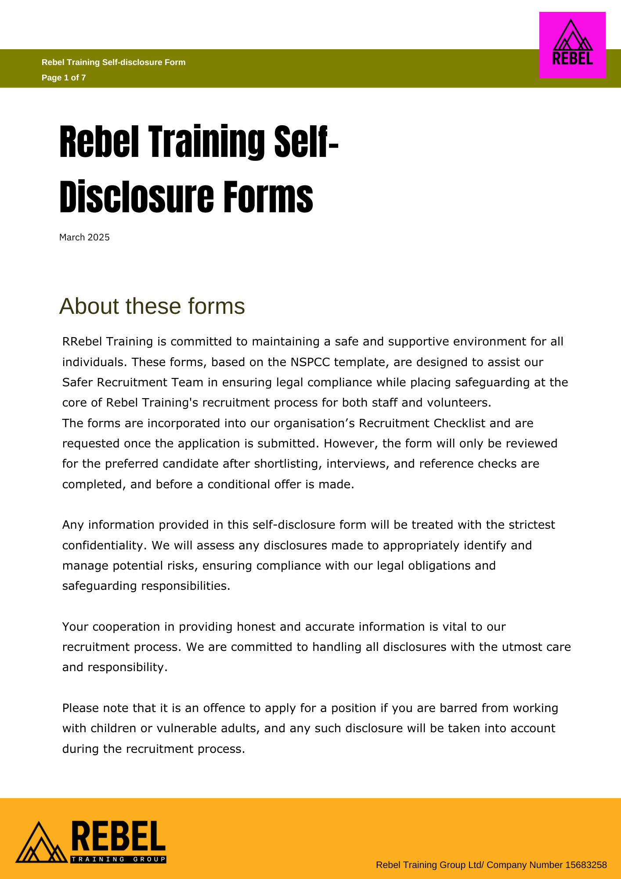

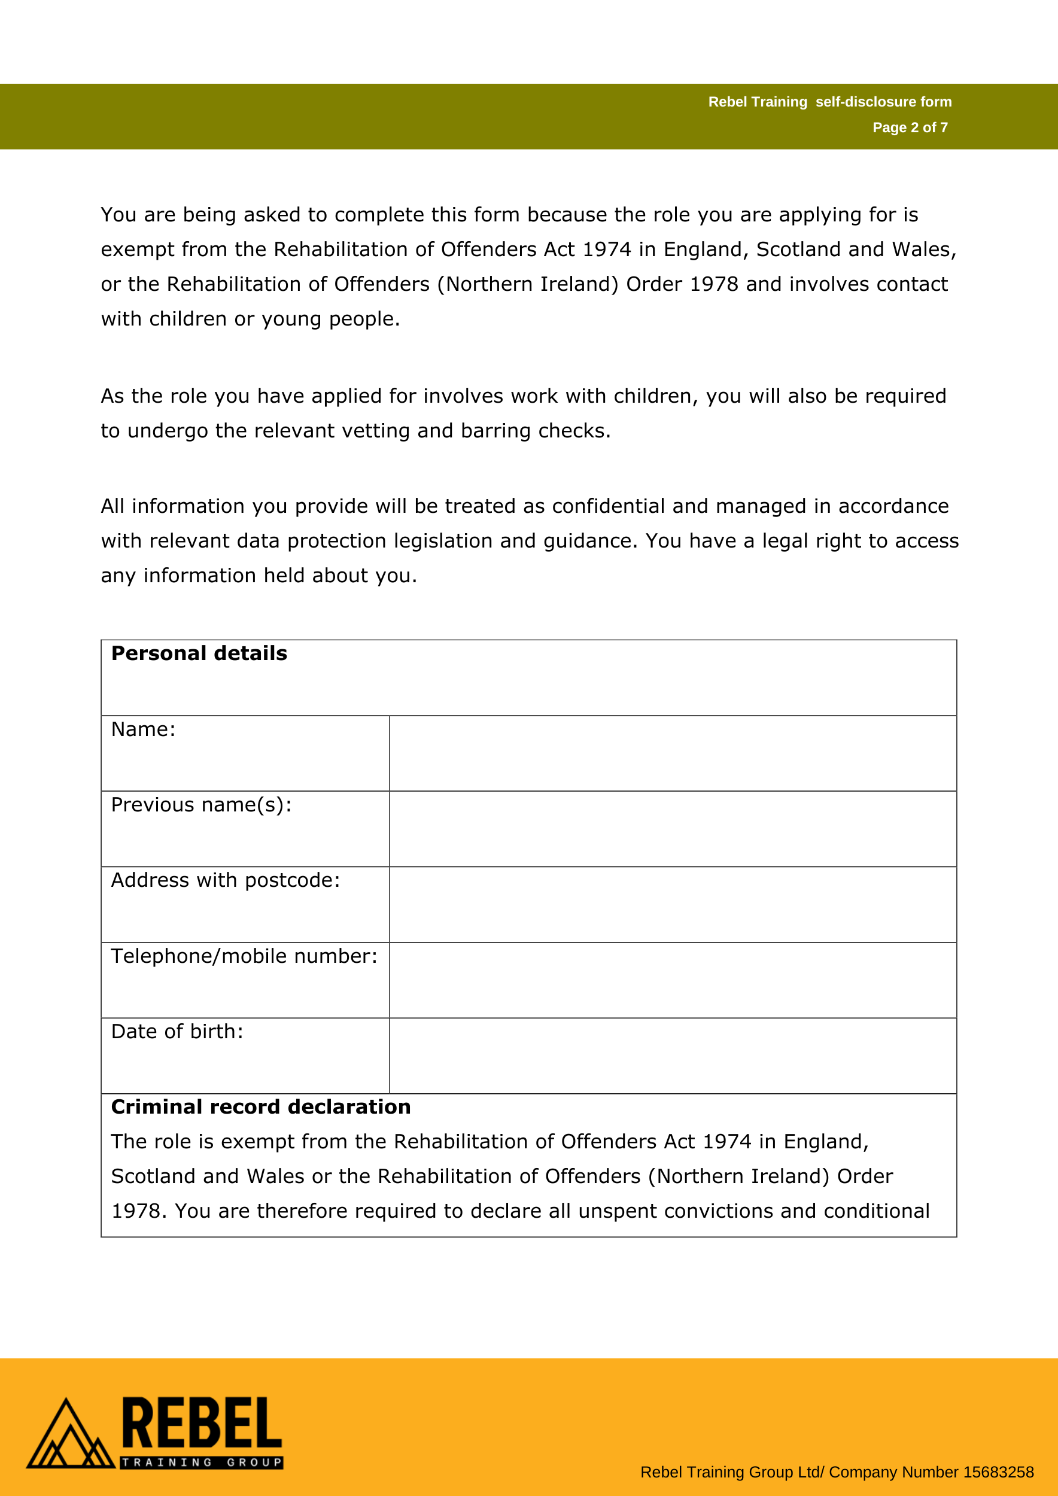

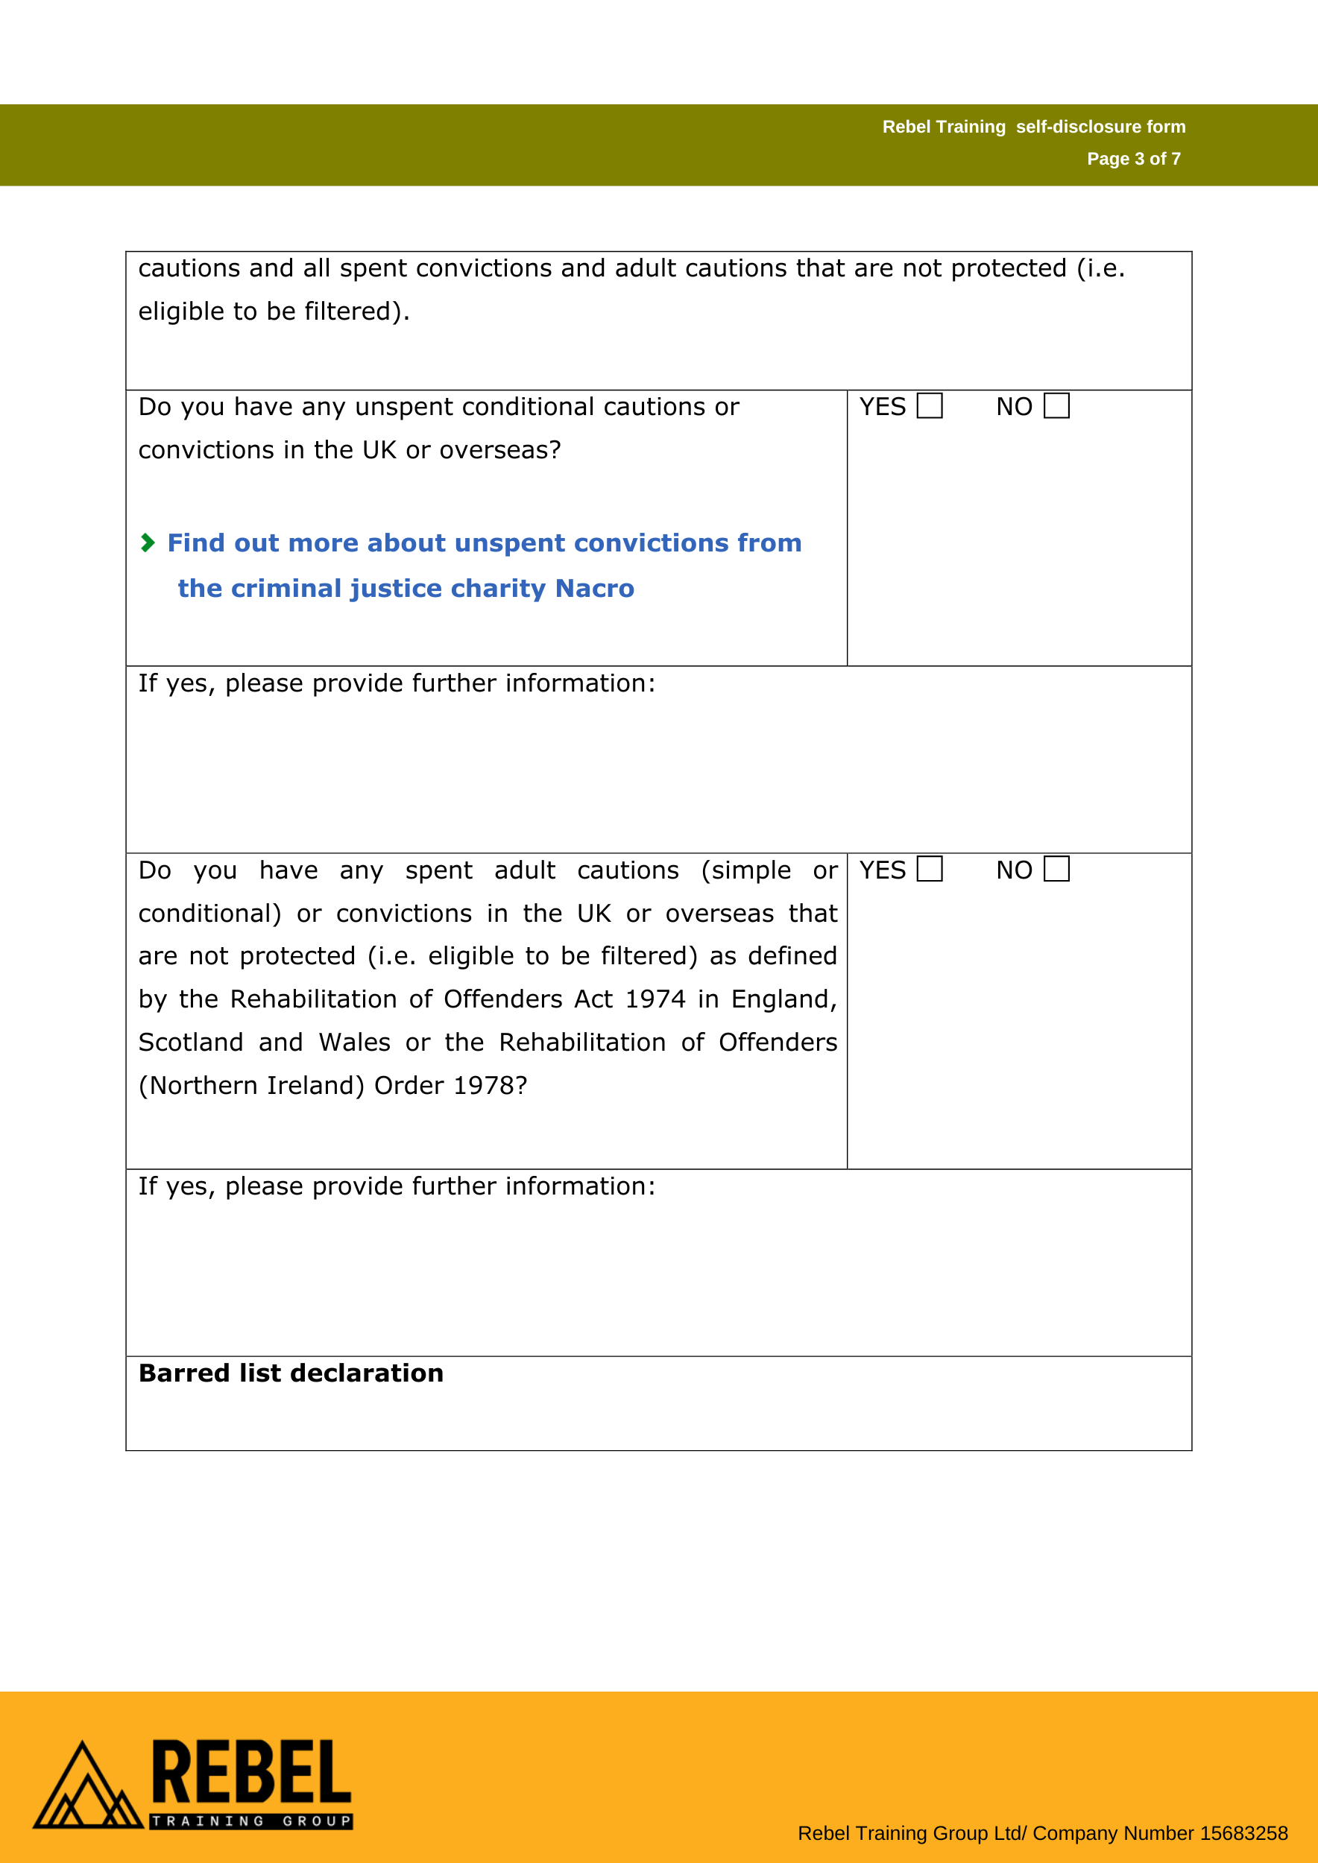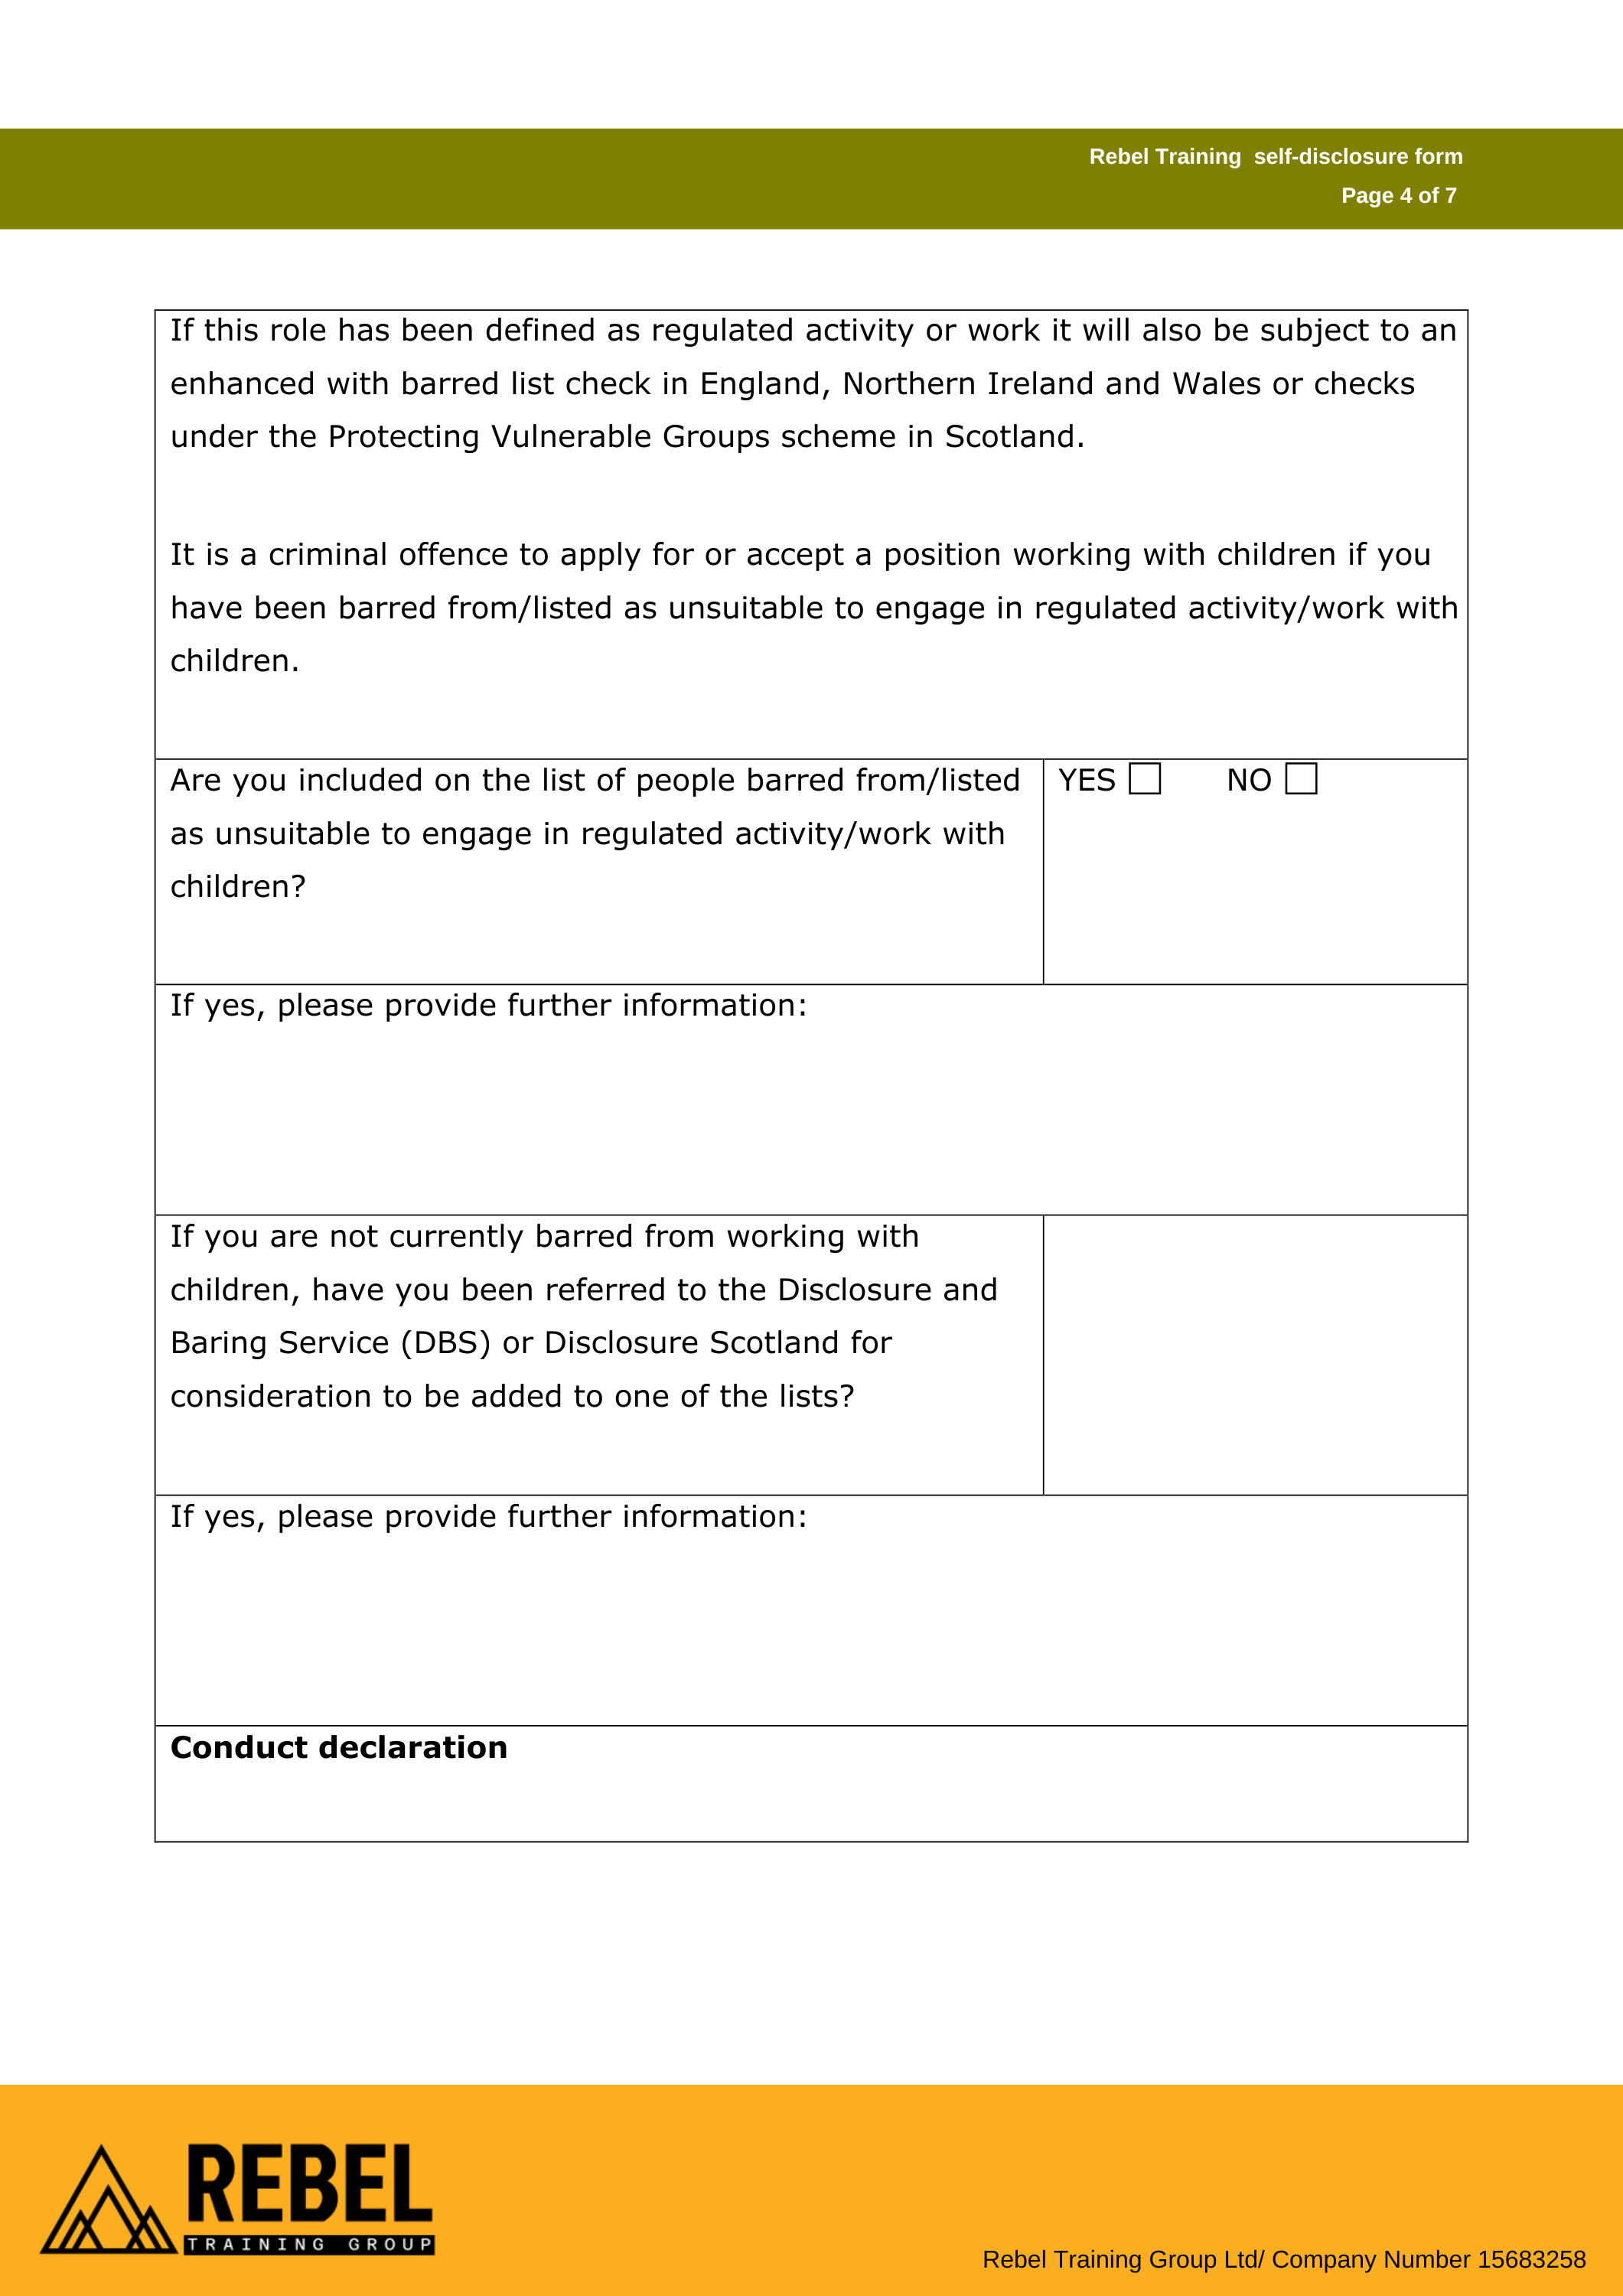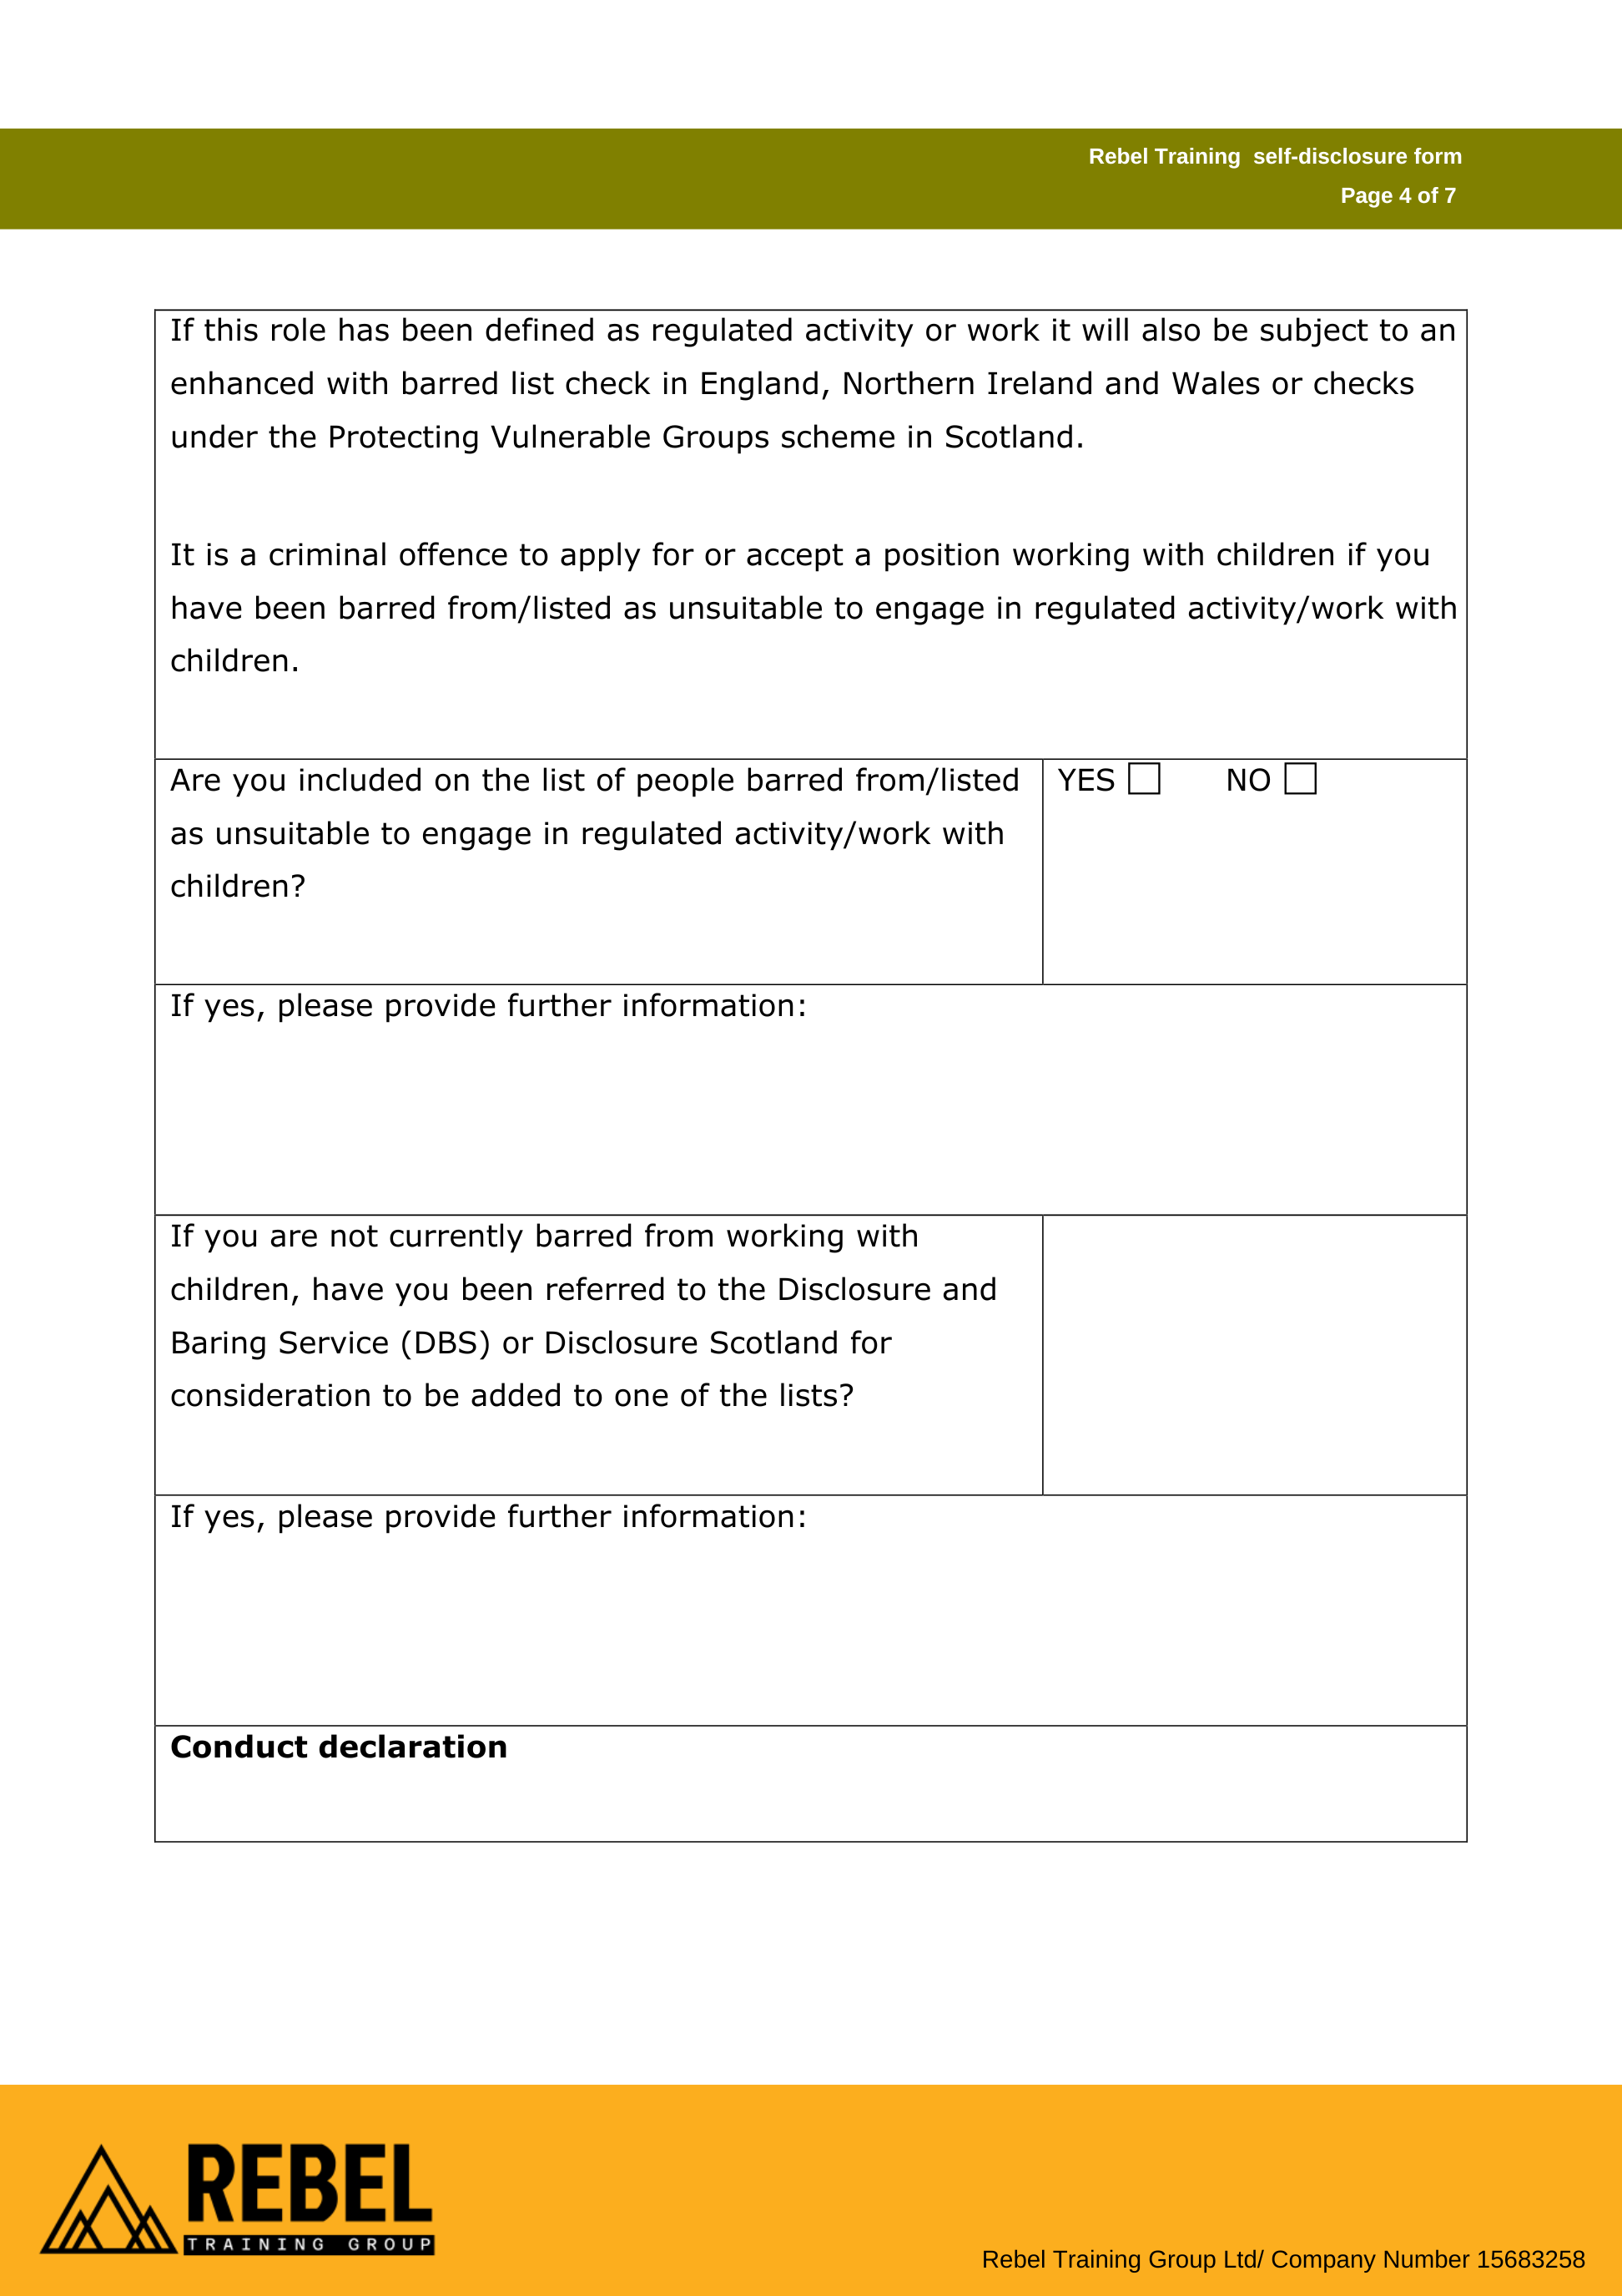

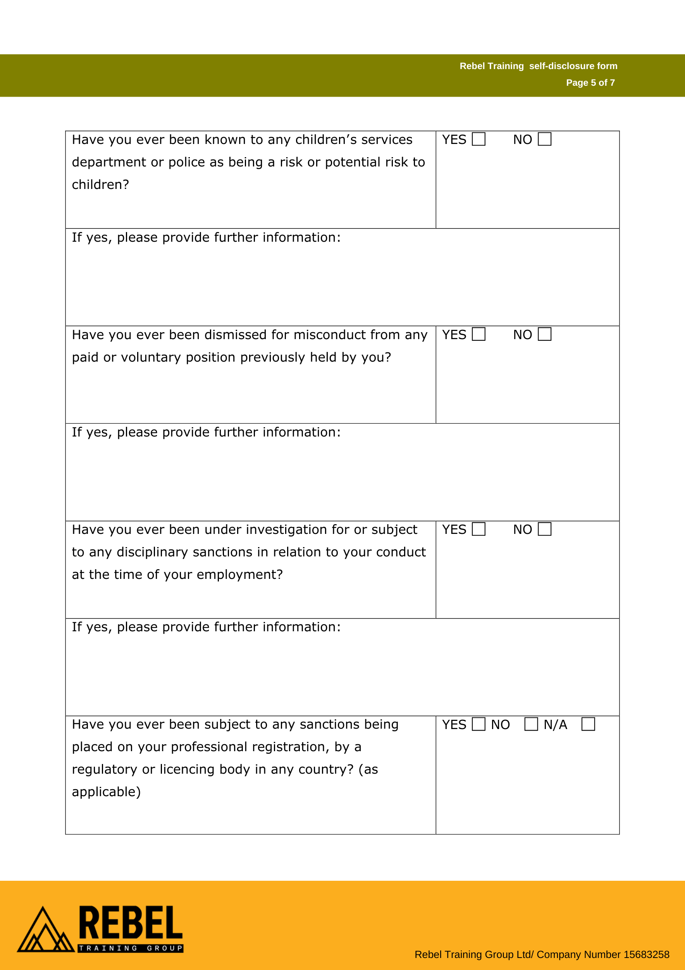

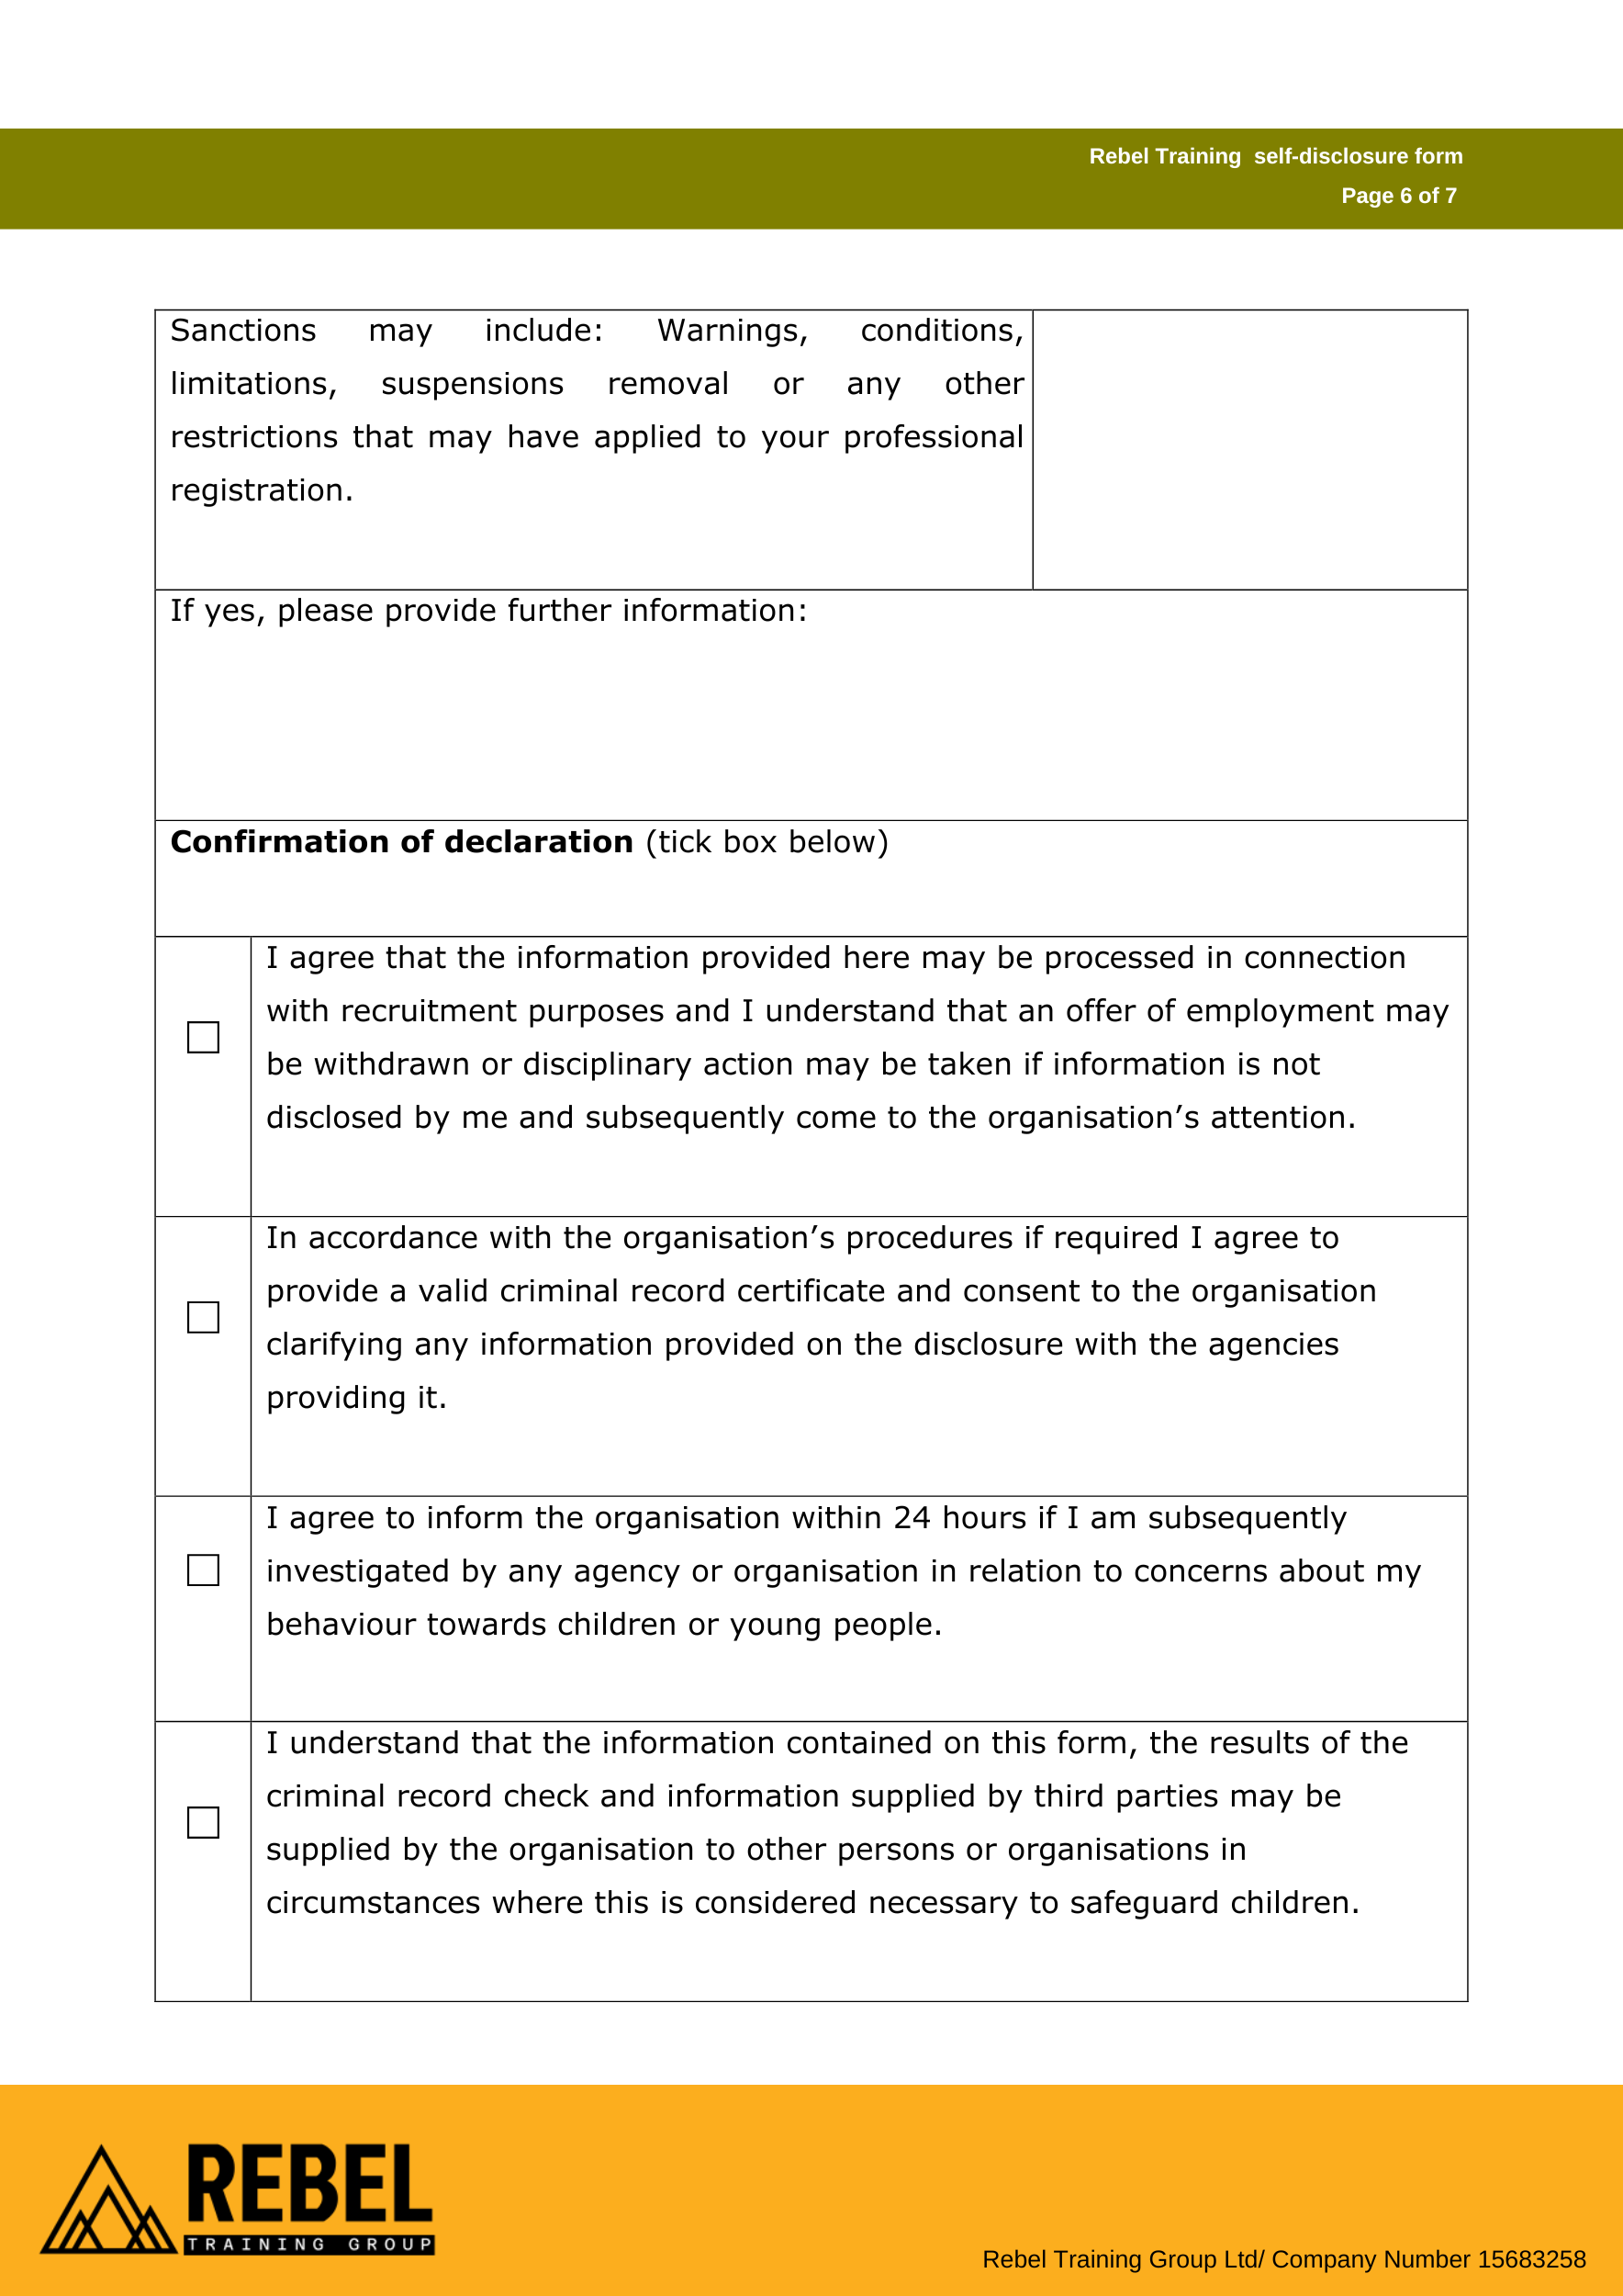

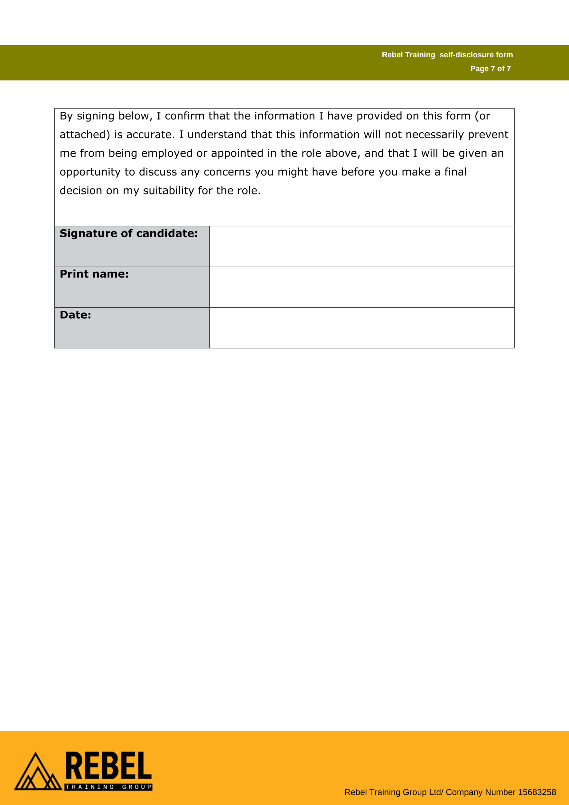

### Appendix 4: Example Interview Safeguarding Questions

### **General Safeguarding Awareness:**

1. Can you describe what safeguarding means to you in the context of youth work?
2. What do you think is the most important thing to keep in mind when working with vulnerable young people?
3. How would you handle a situation where a young person disclosed abuse or neglect to you?
4. What steps would you take if you witnessed or suspected a colleague of acting inappropriately with a young person?
5. How would you ensure that your practice adheres to safeguarding policies and procedures?

### **Practical Safeguarding Scenarios:**

1. If a young person confides in you about a situation where they feel unsafe, how would you respond?
2. How would you manage a situation where a young person refuses to disclose information, even though you suspect they may be at risk?
3. Can you provide an example of how you have previously responded to safeguarding concerns in a professional setting?
4. What would you do if you noticed a pattern of concerning behaviour from a young person, such as frequent absences, unexplained injuries, or changes in mood?

### **Risk Management:**

1. How would you assess and manage risks to young people in a youth work setting, particularly when planning activities or excursions?
2. How would you ensure that young people are aware of how to report concerns about their own safety or the safety of others?
3. What measures would you put in place to protect both young people and staff from potential harm in your role as a Youth Worker?

### **Safer Recruitment and Background Checks:**

1. What steps would you take to ensure that all volunteers and staff members you work with understand the importance of safeguarding and follow best practices?
2. How would you ensure that safeguarding training is continuously updated for yourself and other youth work colleagues?

### **Collaboration with Others:**

1. How would you work with other agencies (e.g., social services, police) if you identified a safeguarding concern?
2. What role do you believe a Youth Worker has in promoting a safeguarding culture within a youth work team?

*These need to be adapted specifically for the role being advertised.

### Appendix 5: Barring Referral Flow Chart

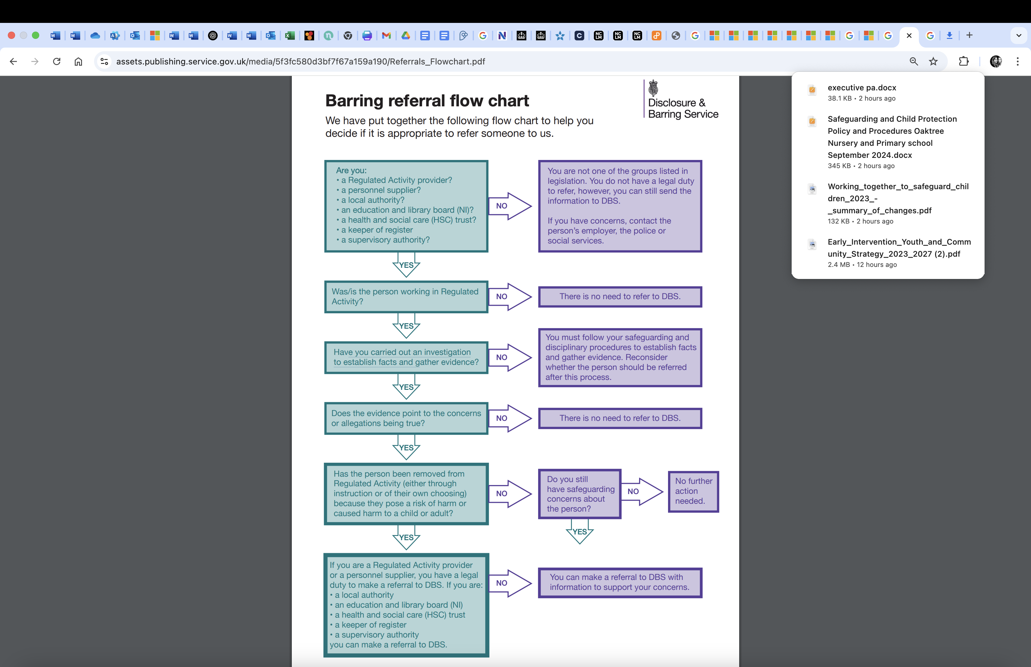See also [Barring Referrals full leaflet](https://assets.publishing.service.gov.uk/media/5c77e3d7ed915d29e5a87e99/CCS0119367774-001_Barring_Referrals_Document__Flowchart_A5_Booklet_V3_DG-2.pdf) for more info.

### Appendix 6: Safer Recruitment Checklist

|  |  |  |
| --- | --- | --- |
| **Actions**  (Complete in this Order) | **Details** | **Completed (Yes/**  **No)** |
| **Job Description and Person Specification** | Ensure that the job description clearly outlines the role, including safeguarding responsibilities, and the person specification includes the necessary skills and experience for working with children and young people. |  |
| **Job Advertisement** | Advertise the role through appropriate channels that will attract a diverse pool of candidates. Include reference to safeguarding responsibilities and commitment to equality and diversity. |  |
| **Application Form** | Ensure that the application form includes questions that assess the candidate’s suitability for the role, including their experience, qualifications, and commitment to safeguarding. |  |
| **Right to Work Check** | Verify the candidate’s right to work in the UK, as applicable, before proceeding to interviews. |  |
| **Self-Declaration Form** | Request that all candidates complete a self-declaration form disclosing any criminal convictions or cautions. See Self-Declaration Form. |  |
| **Shortlisting** | Review applications against the job description and person specification. Ensure any concerns about a candidate’s suitability are noted. |  |
| **Interview Process** | Conduct an interview to assess the candidate’s experience, skills, and suitability for the role. Use safer recruitment questions, including safeguarding-specific questions. |  |
| **Interview Panel** | Ensure that at least two members of staff are involved in the interview process, including one with safeguarding expertise. |  |
| **References** | Obtain two references (at least one from a previous employer) that can speak to the candidate’s suitability for working with children or vulnerable individuals. |  |
| **Open the Self-Declaration Form** | Only for the preferred candidate after satisfactory references. |  |
| **Criminal Record Check (DBS)** | Request an Enhanced DBS check for all candidates involved in regulated activity. Ensure checks are clear and that the candidate has not been barred from working with children. |  |
| **Conditional Offer** | Make a conditional offer of employment, subject to successful completion of all checks, including DBS, references, and the right to work check. |  |
| **Safeguarding Training** | Ensure that all shortlisted candidates are aware of the Centre’s safeguarding policy and that appropriate safeguarding training is offered. |  |
| **Staff Induction** | Provide a thorough induction for new hires that includes training on safeguarding, policies, and procedures. |  |
| **Probationary Period** | Ensure that a probationary period is included in the contract, during which the candidate’s performance and suitability are assessed. |  |
| **Record Keeping** | Ensure that all documentation related to the recruitment process (e.g., application forms, references, DBS checks, interview notes) is stored securely and in compliance with data protection laws. |  |
| **Ongoing Monitoring and Support** | Establish a process for ongoing supervision and support during the probationary period and beyond to ensure the employee’s continued suitability for the role. |  |

### Appendix 7: Version History

|  |  |  |  |
| --- | --- | --- | --- |
| Version | Date Published | Changed made | Changed made by |
| 1.1 | 2 April 2025 | Policy created. Was previously a section of the Safeguarding Policy. Added new links to [*Regulated activity with children in England and Wales (Updated 21 February 2025)*](https://www.gov.uk/government/publications/dbs-guidance-leaflets/regulated-activity-with-children#specified-establishments-with-children)  Added appendix documents/guidance to support business continuity. | Jo Vertannes |